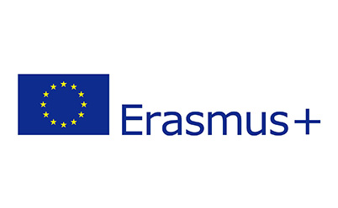Logo_Gross_L

Interview – Initial Vocational Training

2014-2020

EU-Program Erasmus+

Name of Participant: ­­­­­­­­.............................……. Name of Interviewer: ................................……

1. Why did you apply for the EU-Program Erasmus+? Please mention your main reason.

...............................................................................................................................................................

...............................................................................................................................................................

2. What are your expectations and hopes for your stay?

...............................................................................................................................................................

...............................................................................................................................................................

3. How do you think this experience is going to affect you in future? How could you benefit from it?

...............................................................................................................................................................

...............................................................................................................................................................

4. Have you ever been abroad or participated in an exchange program before? If yes, where?

...............................................................................................................................................................

...............................................................................................................................................................

5. Do you accept to be placed in a position which is not directly related to your field of study?

🞎 a) Yes, I understand that my placement may be in a different field 🞎 b) No, I refuse

6. Please list 3 expected daily tasks at work, if you had the choice to decide.

...............................................................................................................................................................

...............................................................................................................................................................

Date, Signature Participant Date, Signature Interviewer